**DAYANANDA SAGAR COLLEGE OF ENGINEERING**

Shavige Malleshwara Hills, Kumarswamy Layout, Bangalore, Karnataka – 560 078



Department of __________________________________________________

Subject with Code ________________________________________________

***Laboratory Certificate***

This is to certify that Mr. / Mrs. ______________________________________

Bearing USN _______________________________ has satisfactorily completed

the experiments in above practical subject prescriber by the Visveswaraya

Technological University, Bangalore for the semester B.E. in the _____________

_______________________________ Laboratory of this college during the year

201____ to 201____.

Date: ________________ _______________________

**Name & Signature of Faculty In-Charge**

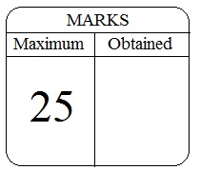 _______________________

**Head of the Department**